*Student Name : YASH GUPTA Branch : CSE*

*ANAND KUSHWAH*

*UID : 20BCS5009 Section/Group : GRP – 1*

*20BCS5039*

*Date of Performance : 05/09/2020 Subject Name :* *DIGITAL*

*ELECTRONICS*

AIM

*TO VERIFY THE TRUTH TABLE FOR :-*

* *AND GATE*
* *OR GATE*
* *NAND GATE*
* *NOR GATE*
* *XOR GATE*
* *XNOR GATE*

TASK TO BE DONE

VRIFY TRUTH TABLE:-

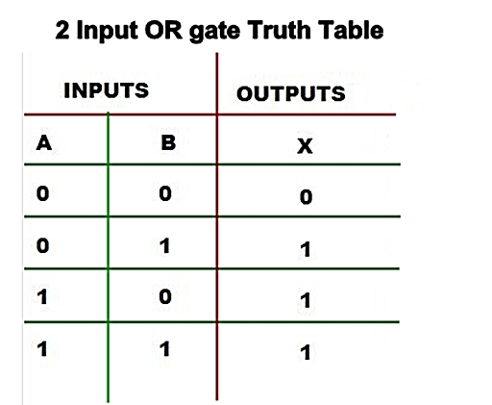



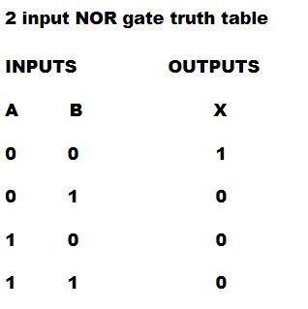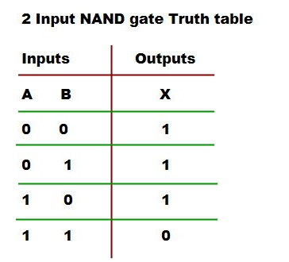

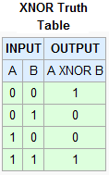

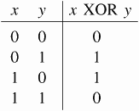

REQUIREMENTS

***Software requirement***

* **Tinkercad**

***Hard ware requirement***

* **Wire**
* **Bread board**
* **Logic Gates**
* **Power supply**
* **Led**
* **Resistor**

CIRCUIT DIAGRAM

***For AND Gate_***

* ***A= 0***
* ***B= 0***

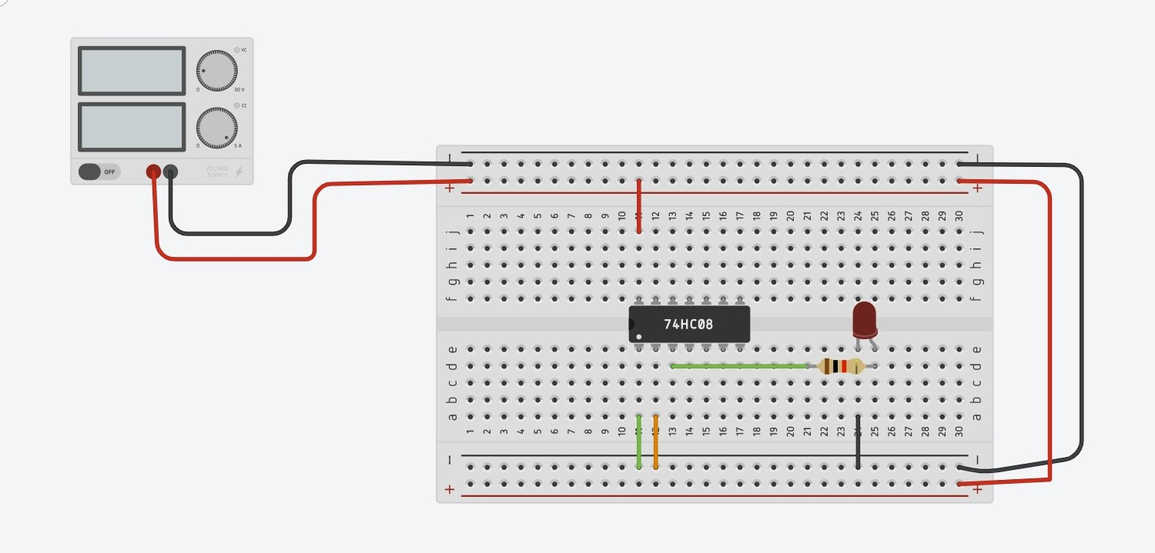



* ***A= 1***



* ***B= 0***

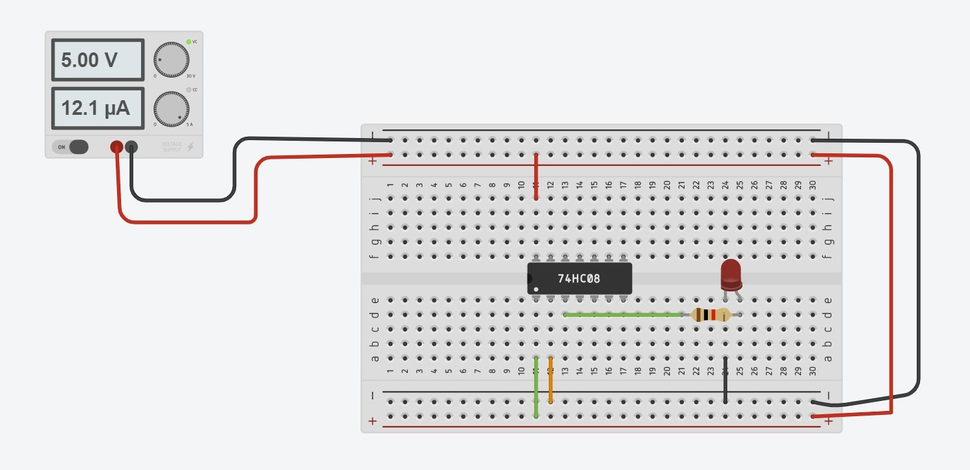

* ***A= 1***
* ***B= 1***

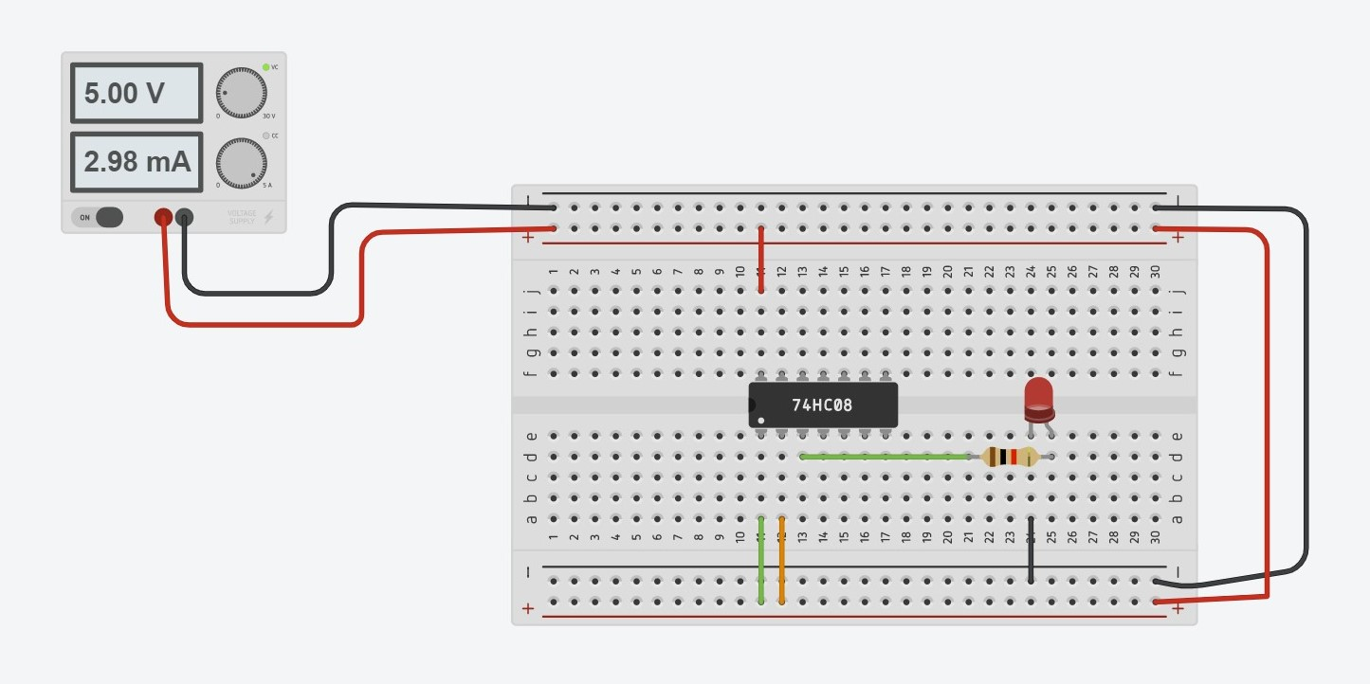

***For NOR Gate_***

* ***A= 0***
* ***B= 0***

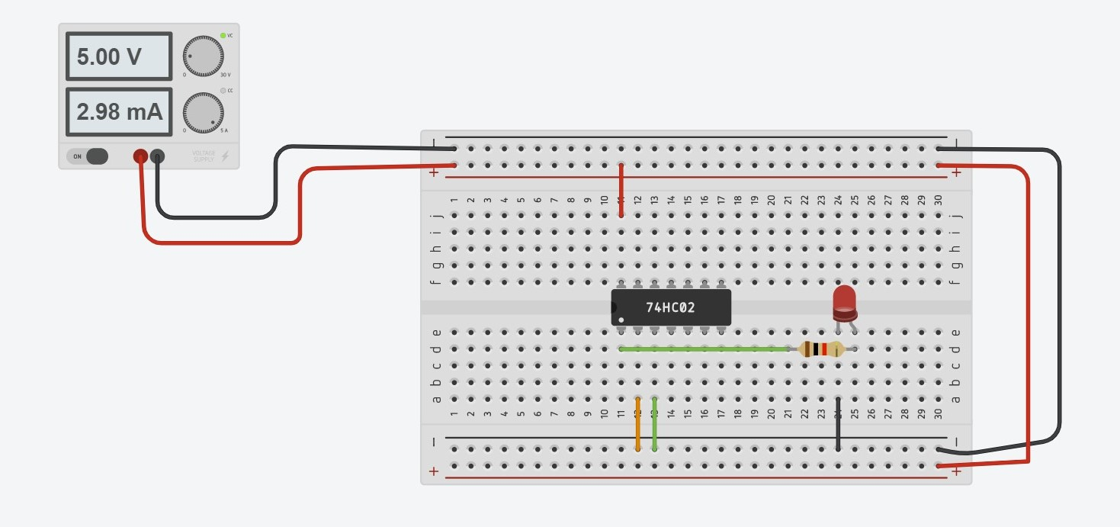

* ***A= 0***
* ***B= 1***

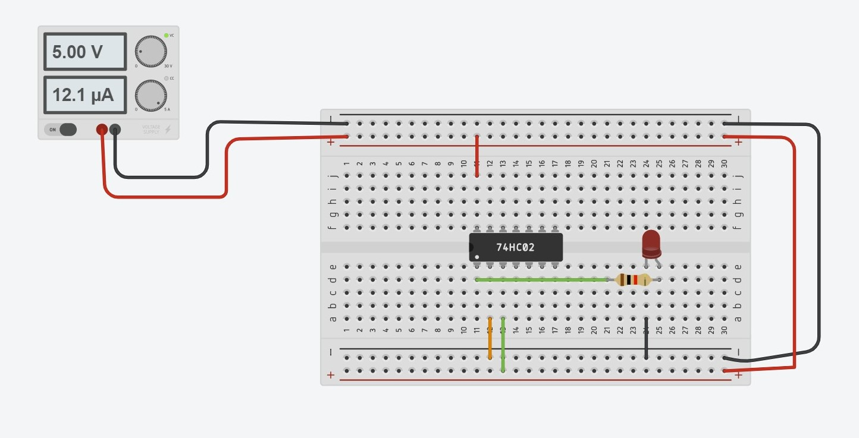

* ***A= 1***
* ***B= 1***

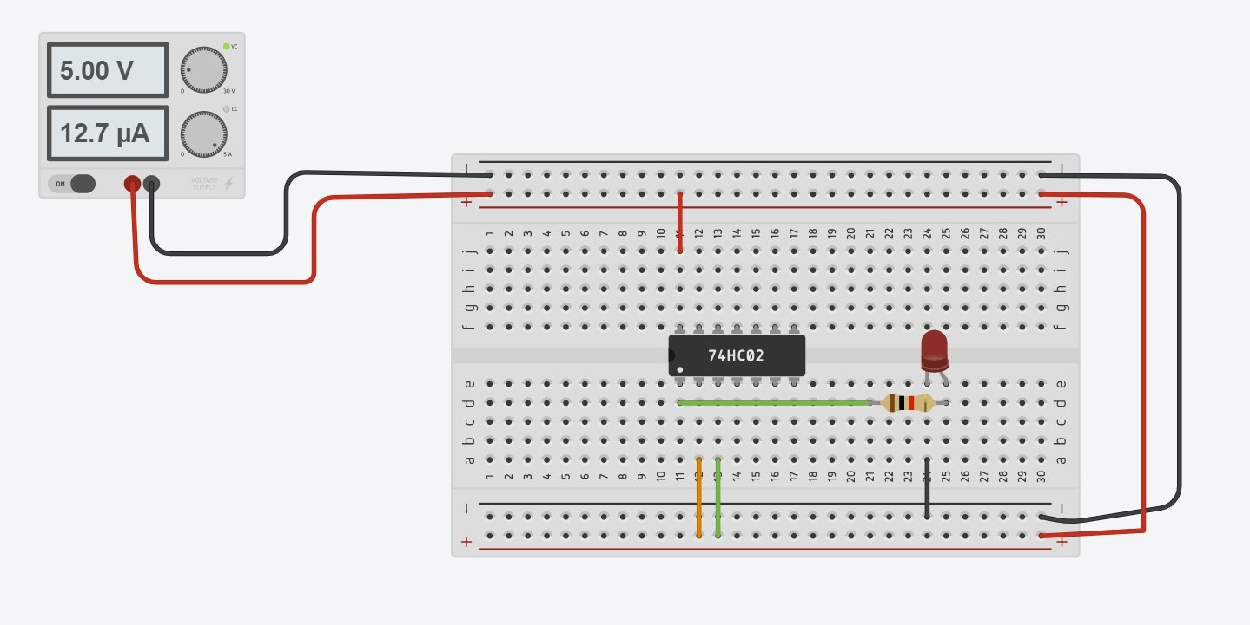

***For NAND Gate_***

* ***A= 1***
* ***B= 0***

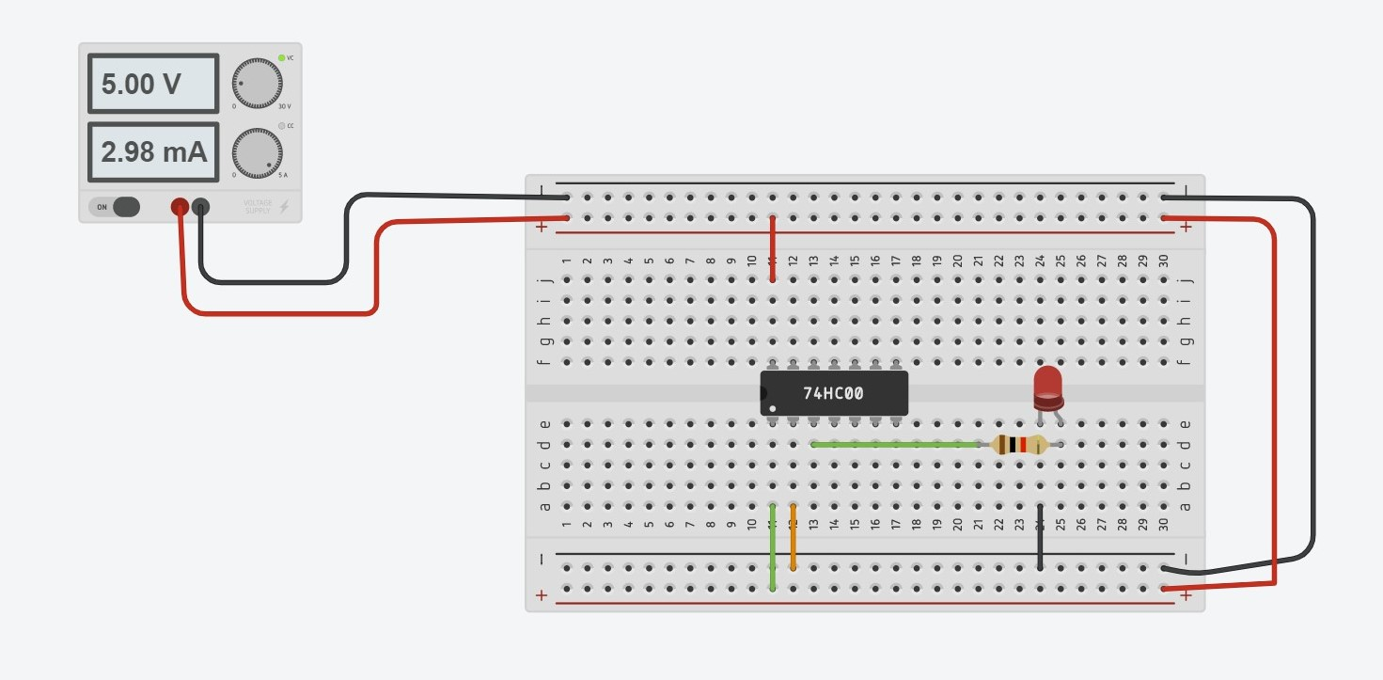

* ***A= 1***
* ***B= 1***

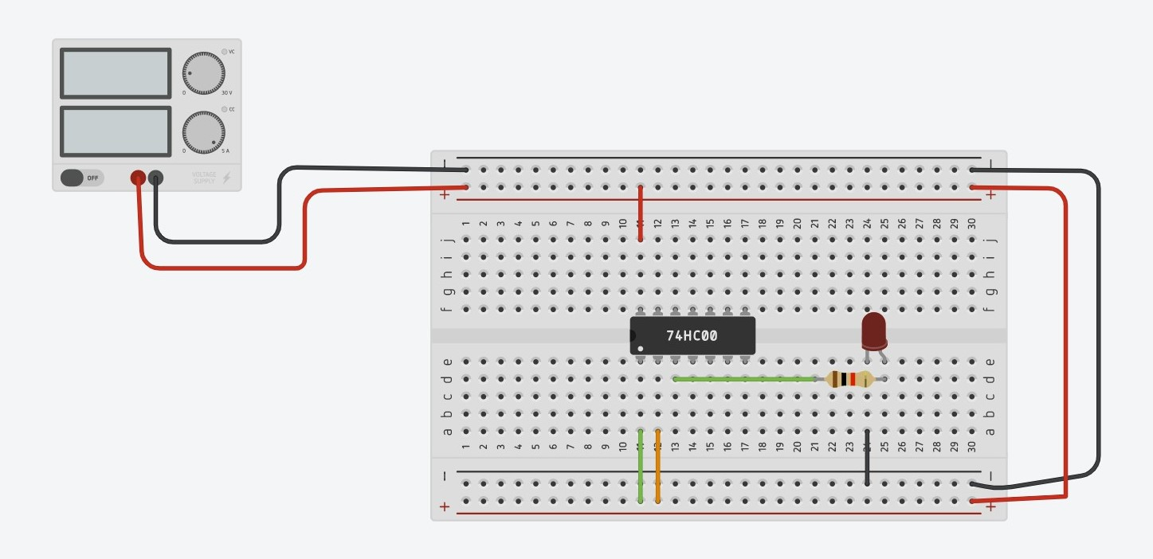

***For XOR Gate_***

* ***A= 1***
* ***B= 1***

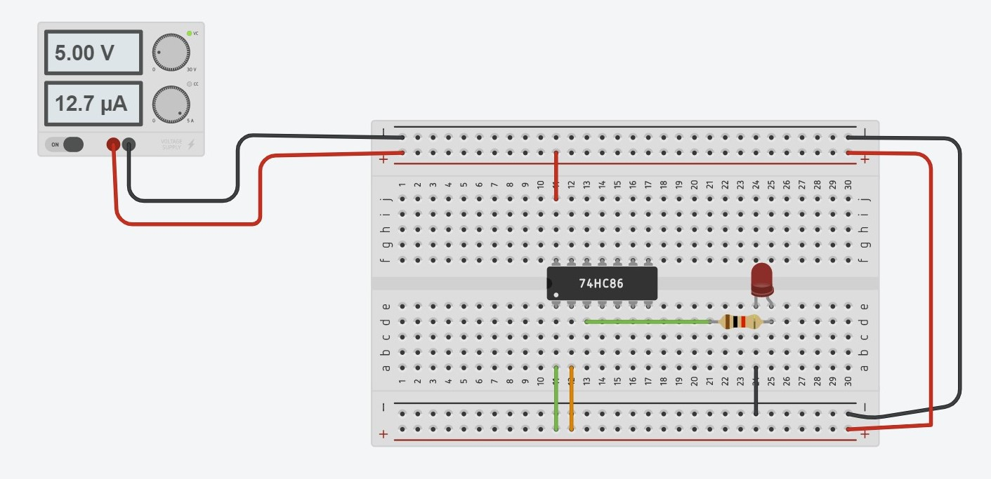

* ***A= 1***
* ***B= 0***

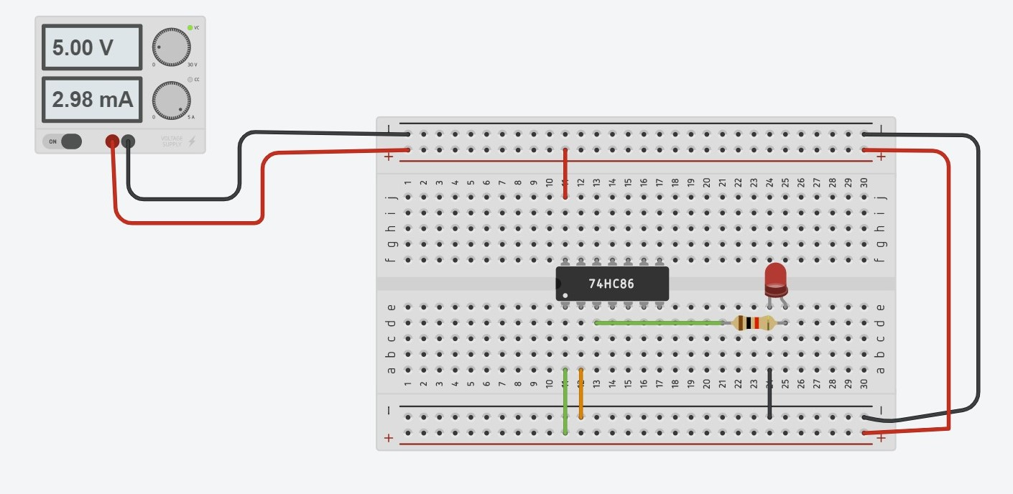

***FOR OR GATE_***

* ***A= 0***
* ***B= 1***

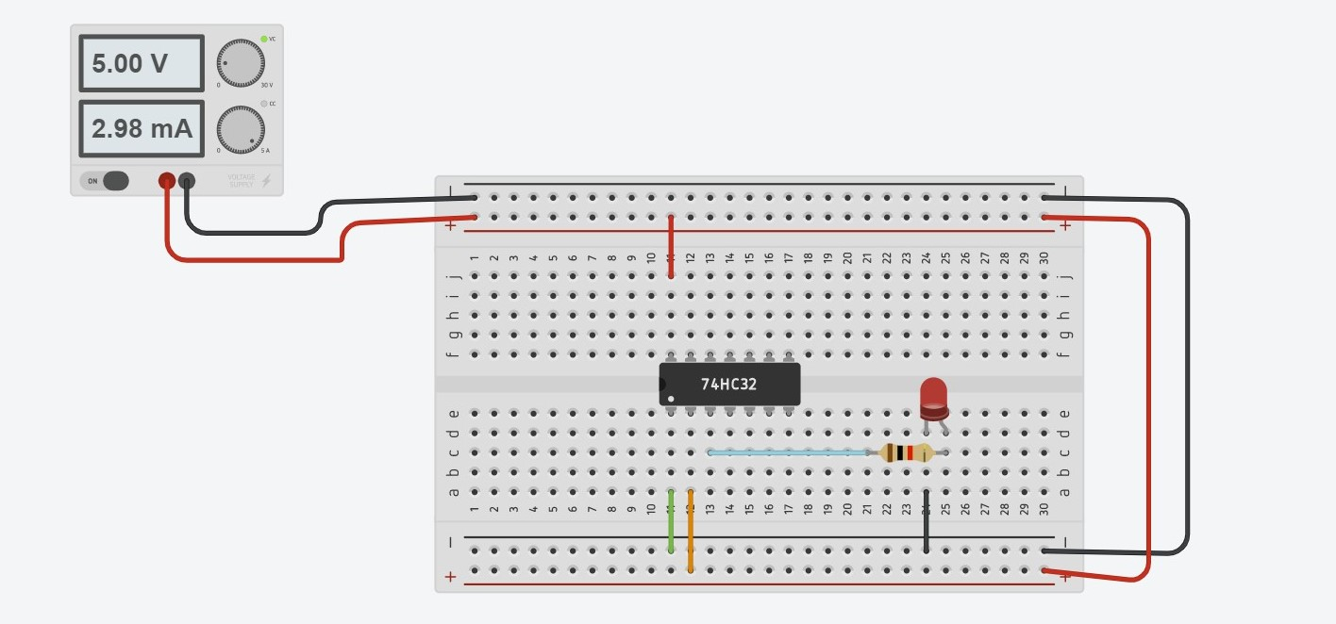

* ***A= 0***
* ***B= 0***

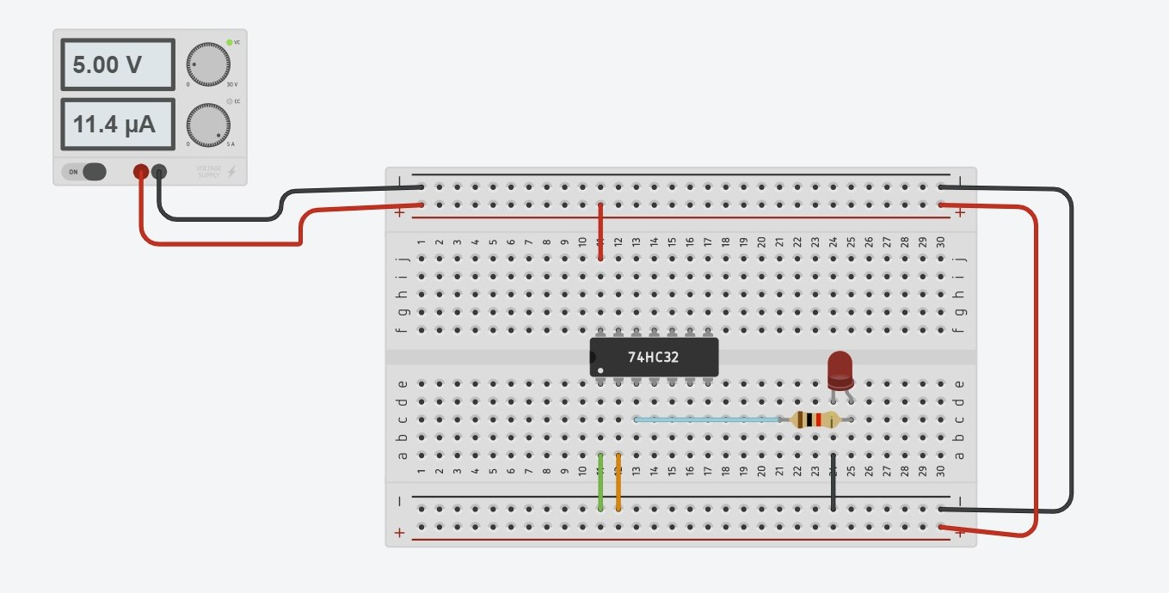

* ***A= 1***
* ***B= 1***

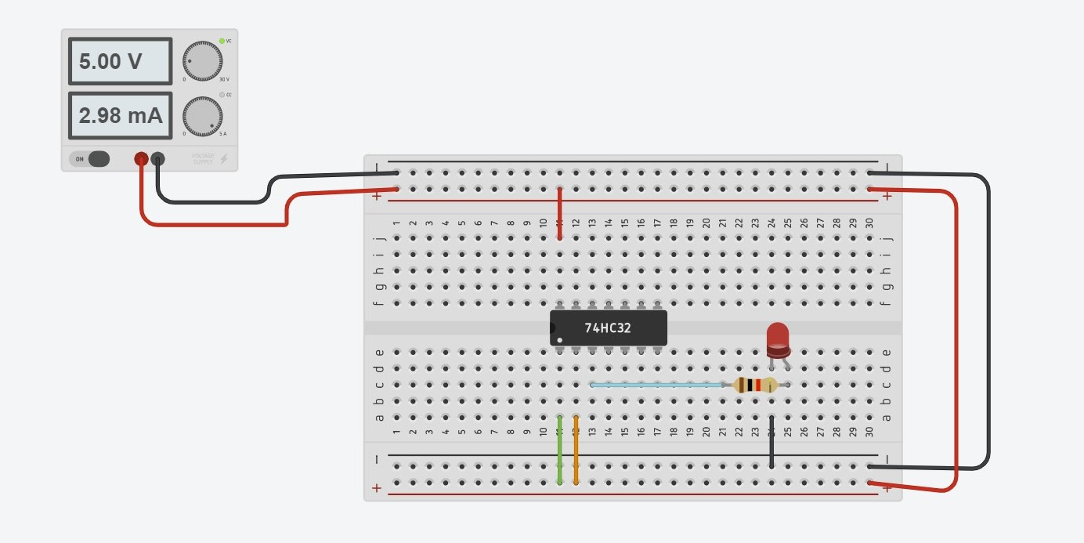

TROUBLESHOOTING

* When the output is true the current flows and the light glows, but due to high voltage the led blows up.
* To over come this problem we use an resistor.

-------------------------------END---------------------------------------